OPERATION & MAINTENANCE MANUAL FOR HIGH SPEED DOOR RR3000ISO

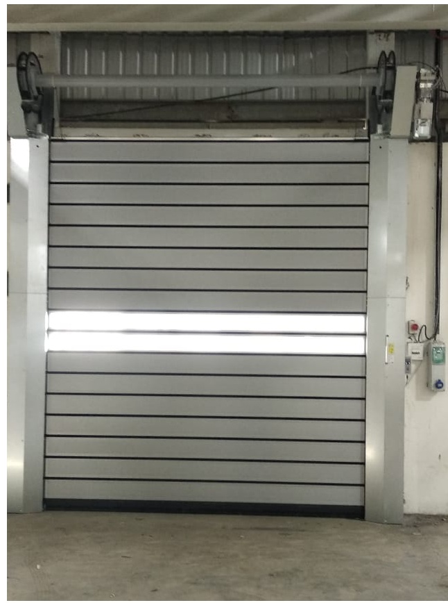

CLIENT: SCON
PROJECT: JOHN DEERE INDIA PVT LTD
MFG.YEAR: 2020

DESIGNED, DEVELOPED & MARKETED BY



Address- G-BLOCK, 1ST FLOOR, THERMAX CHOWK MIDC, ABOVE RENAULT SHOWROOM CHINCHWAD, PUNE-411019
TEL.NO: - +912066304033
EMAIL: -info@nihva.com

www.nihva.com

PRODUCT – ASSA ABLOY HIGH SPEED DOOR RR3000ISO
SIZE | REFER SIZE TABLE PG. NO 2
PO NO | JHNDREE10487
Prepared By | Siddheshwar Shelake
Date | 23.12.2020

HIGH SPEED DOOR DIMENSIONS:

SR NO | CLEAR WIDTH (CW) mm | CLEAR HEIGHT  (CH) mm | QUANITY | REMARK
1 | 3000 | 3500 | 1 | SOUTH SIDE
2 | 3885 | 4500 | 1 | EAST SIDE
3 | 4500 | 4500 | 1 | EAST SIDE
4 | 3990 | 4000 | 1 | WEST SIDE
5 | 4000 | 4450 | 1 | WEST SIDE
6 | 4000 | 5000 | 1 | WEST SIDE
7 | 4000 | 4500 | 2 | NORTH SIDE
8 | 6000 | 5990 | 1 | NORTH SIDE

DISPATCH & UNLOADING

- Loading for dispatch will be our responsibility. On receipt of the High-speed door at site, please check and ensure that there is no physical damage to the equipment.

- While unloading the equipment from the transporting vehicle, please ensure to use slings with rated capacity higher than the gross weight of the Stationary lift in packed condition.

ORDERING OF SPARES

  - When ordering for spare, please specify the following in your Purchase Order.

    - High Speed door size
    - Part name / Description
    - Quantity required
    - Delivery period / time
    - Mode of dispatch

This would avoid ambiguity and help us serve you better.

      - EMERGENCY CONTACT DETAILS: -

        - Service Department - 9168938333
        - Project Department - 8551095333

INTRODUCTION

The Albany RR3000 ISO combines the superior thermal performance of a sectional door with the fast speeds and operational efficiency of a high-speed roller door with flexible curtain. This next generation, hybrid solution from ASSA ABLOY Entrance Systems opens and closes with maximum speed and minimum energy loss.

PRE – OPERATING INSTRUCTIONS: -

- The high-speed door system may only be operated by persons who have been instructed in its proper use.
- The high-speed door system opens & closes vertically upwards & downwards. When in operation, make sure that neither persons-children in particular- nor objects are located within the high-speed door’s area of travel.
- You are responsible for ensuring that children cannot operate high speed door system, neither via the control nor control elements.
- Wait until the high-speed door has come to a complete halt before walking/driving into the high-speed door’s area of travel.
- Never use the high-speed door to lift objects and/or persons.
- Whenever driving in or out of the opening, always check that the high-speed door curtain has travelled up far enough to provide the necessary passage height.
- Only ever operate the high-speed door system when all the protective devices & safety equipment’s are fitted & are in perfect working order.
- Do not dismantle or alter any of the protective devices. Do not put any of the protective devices out of operation.
- Protect the high-speed door from aggressive & caustic substances in order to avoid damage due to incorrect handling of high-speed door system.
- The high-speed door system is intended for temperature range of -10⁰C to +40⁰C & relative humidity is 0% to 60%.
- In the case of malfunction call NIHVA immediately for inspect & repair the high-speed door system.
- Only use original spare parts. They always meet the technical requirements laid out by us.

SAFETY INSTRUCTIONS: -
    - Before performing any maintenance and cleaning work, disconnect the door from the mains by switching off the lockable main switch on the switch box or unplugging the CEE connector.
    - Use a meter or other test device, verify that the switch box is de-energised.
    - Please observe that all used ladders, scaffoldings, or such, correspond with the valid safety regulations.
    - The working area must be blocked for traffic. Lubricating oil on the floor, tools and other material should be removed from the floor when work has been finished.

TECHNICAL SPECIFICATIONS: -

- MAKE- Albany RR3000 ISO
- SIZE- REFER SIZE TABLE
- DRIVE-Electrical Gear Motor
- DRIVE OUTPUT- 400 V 3 Phase 50Hz
- Motor Performance- 1.1kW
- Control Unit – MCC
- Control Voltage- 24 V DC
- Operating Temperature Range - -10⁰C to +40⁰C
- Motor Protection- IP55
- Sound Pressure Level-70Db
- Maximum Opening Speed- 2.1m/sec
- Maximum Closing Speed- 0.7m/sec
CONTROL UNIT-

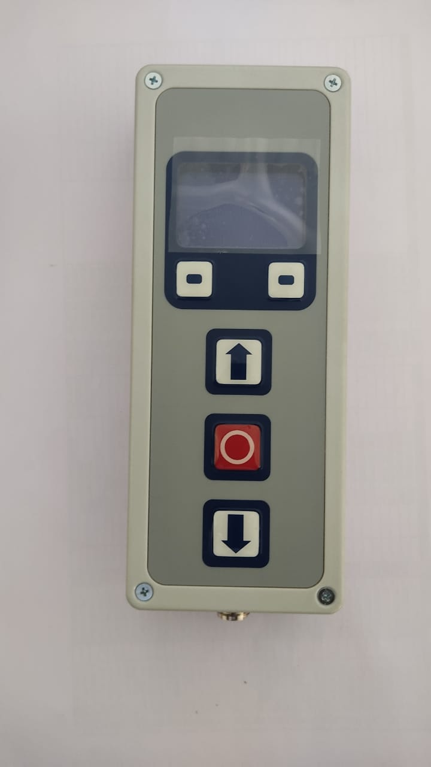

UP BUTTONUTTON
STOP BUTTON

DOWN BUTTON

GA DRAWING:
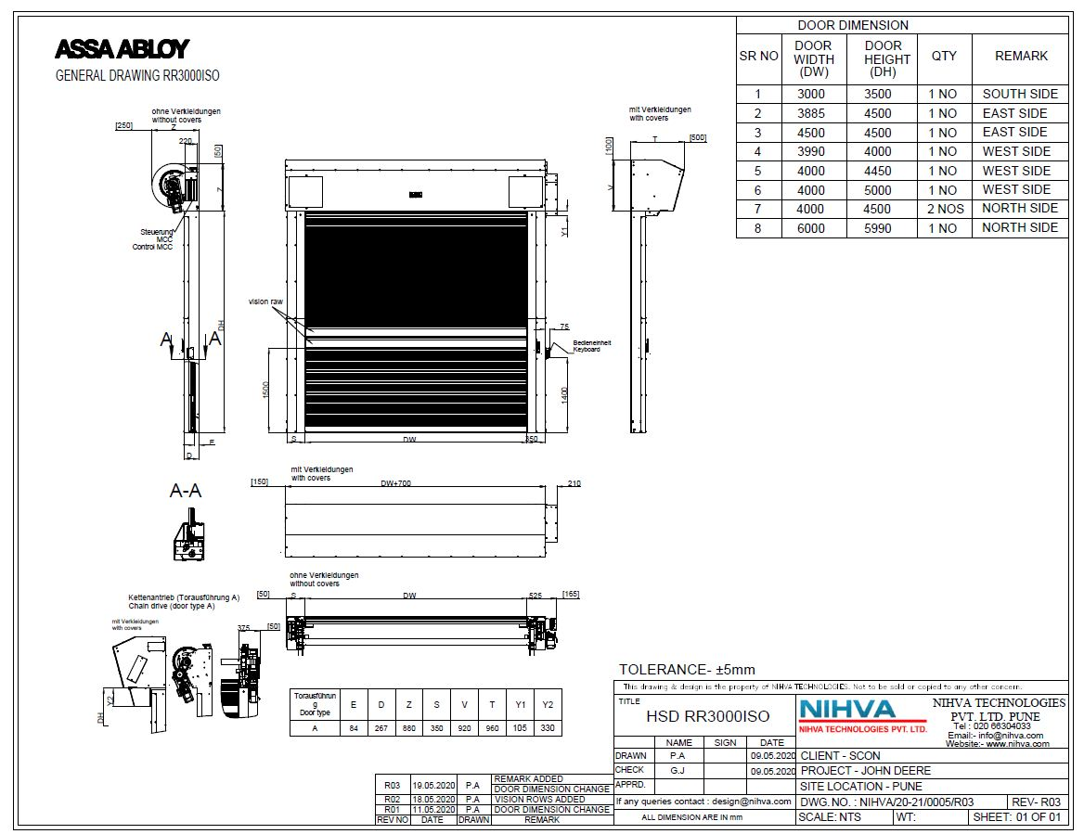
STANDARD SPARES & ACCESSORIES-

- Side Frame
- Panel door blade
- Top Roll
- Spring
- Drive Unit
- Top Roll Cover
- Motor Cover
- Control Unit

ROUTINE MAINTENANCE

As the owner or operator of the door, you must have the system inspected & maintained by NIHVA/specialist once a year in. Refer service interval charts for individual componentrs.

DAILY:
- Do visual inspection for mechanical damage to product.
- Ensure proper voltage & all electrical connections are proper before operating.
- Clean the lenses & reflectors regularly with a soft, dry lint-free towel.

Appendix Inspection
The following tables list inspection plans for the doors. The overview of the service intervals is provided in section B 1. The numbers are used in the inspection plan 0.

B 1. Service intervals

1 | half-yearly or 50.000 cycles
2 | annually or 50.000 cycles
3 | annually or 100.000 cycles
4 | annually
5 | clean if necessary
6 | every 4 years
7 | 150.000 cycles
8 | 250.000 cycles
9 | 500.000 cycles
10 | 150.000 cycles; RR300 Plus F+R: 100.000 cycles
11 | with MCC: 150.000 cycles; with ACS50: 50.000 cycles
12 | RR450Ex / 600Ex: 200.000 cycles
13 | 450.000 cycles; RR450Ex/600Ex 200.000 cycles
14 | 200.000 cycles; RR600 Crash: 100.000 cycles
15 | DH < 3m: 500.000 cycles; DH ≥ 3m: 250.000 cycles
16 | DH < 4m: 300.000 cycles; DH ≥ 4m: 200.000 cycles
** | Exchange of bearings only by drive manufacturer or an approved workshop for the maintenance of the explosion-proof ness. (downtime at the time of external execution of the exchange, which can be expected, approx. 8-10 working days)
*** | Regular conditions: central European climate, door mounted interior or exterior with covers, no aggressive ambient conditions
≤150.000 cycles: ±10.000 cycles; >150.000 cycles: ±20.000 cycles

B 2. Inspection plan

Inspection | RR3000 ISO
Installation fixings
Tighten screws | 3
Check welding seams | 3
Drive
Check the fixing of the torque arm and buffer | 3
Check brake condition and function of break release lever | 3
Check operation smoothness and function of the emergency manual lever, maybe lubricate | 3
Check the chain, adjust and possibly re tension and lubricate | 2
Drive shaft
Check screws to drive shafts and flange bearings | 3
Lubricate pedestal bearing and retighten its fixation
Check the drive shaft in the aluminium shaft for secure fit
Check tight position of belt and rope discs
Check the condition of the cable drums
Check retainer of spiral disk on the shaft | 3
Chain drive: check fastening of locking element, tighten the screws with 18 Nm | 2
Check condition of sound isolation profiles at the spiral disks | 2
Check flat belts for wear and damage; check  connection to spiral disks | 2
Door curtain
Check curtain for cracks and traces of scrapes or shavings in the guides | 2
Check fixation of door leaf at the top roll and at the bottom profile
Check tight position and wear & tear of the wind tabs
Belt: condition, lubrication, wear; if necessary replace teeth
Check exact position of slat sealing | 3
Check fixing of slats on pulling device and endcaps | 2

Inspection | RR3000 ISO
Check slats around adapters for damage (especially 1-5 from top) | 2
Check solid position of slat adapter | 3
Bottom profile
Check tight fit and condition of profile, guiding pieces and the gliding pieces
Check condition of the safety edge and the cable
Check condition of the coily cable
Check the condition and function of the crash system
Check condition and function of wireless safety edge; change battery if necessary
side frame
Check fixing and condition of the profiles with attachments | 3
Check cable laying and if applicable cable chain | 3
Remove dirt from the photocell optics | 5
Check condition, fixing and lengthwise extension of the ropes and belts | 2
Check the condition and function of the counterweight system | 2
Check condition and installation of the springs and the spring mounting, if applicable check for easy movement of the axial bearing
Doors with ripped belt / rope or broken springs are to be immediately taken out of service
Check leaf tensioning system
Check for wear & tear (s) on guiding rails, especially in the area of funnel (s< 4mm) | 3
Renew belt/s | 16
Renew spring/s | 16
Renew ropes
Renew ropes and pulleys for counterbalance
Renew ropes or rubber cable for curtain tension
Renew flat belt*** | 9
Grease plastic guiding

Inspection | RR3000 ISO
Control box and additional attachments (e.g. impulse activator)
Check for full number/completeness of circuit diagrams | 4
Check main switch/CEE-plug and control box lock | 4
Check the fixing | 4
Electrical components
Visual inspection for mechanical damage | 2
Check potential balance | 4
Safety equipment and impulse activators
Measure self-opening height after switching off the door and document in the inspection logbook (minimum self-opening height: 2m)
Check self-test function by switching the key switch or switching the door On/Off
Function
Check function of safety edge, photocell, additional safeties and actuators | 1
Check function and condition of the torque arm during operation | 2
Assess possibility of emergency opening | 2
Check opening and closing position of the bottom profile | 2
Check winding performance of door curtain and ropes/belts | 2
Check function of belt and spring break switch
Check function of magnetic switch at 2m door height
Check radar motion detectors for mechanical damage and that they function properly (required detection range: whole door width, up to 1.5m in front of the door)
Check main closing edge according to EN 13241-1 respectively local standards | 4

